**U.A. High School_Solution_Documentation**

**Written by: Yuval Quina**

1. To begin with, I started the challenge with Nmap port scanning:

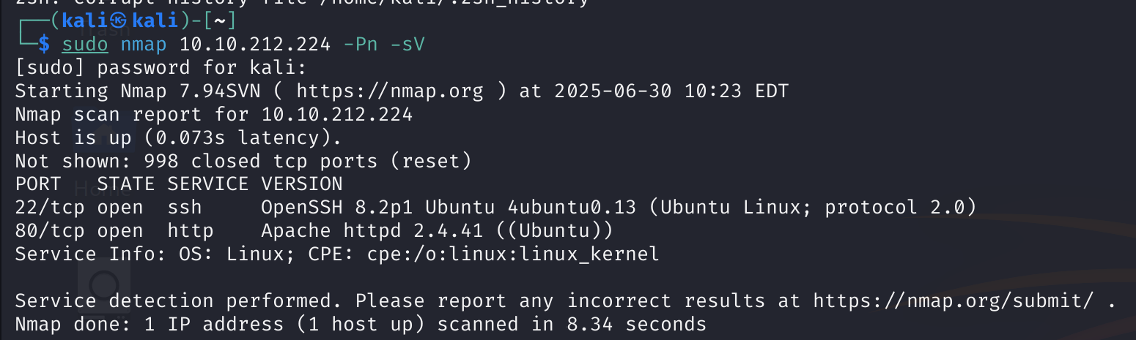

After completing the scanning, I opened the target’s website:

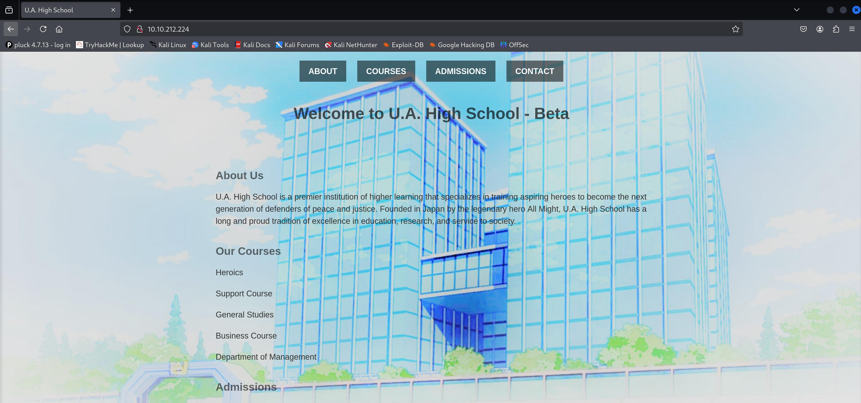

1. From that point, I did several things.

First of all, I performed a directories enumeration using “gobuster” tool:

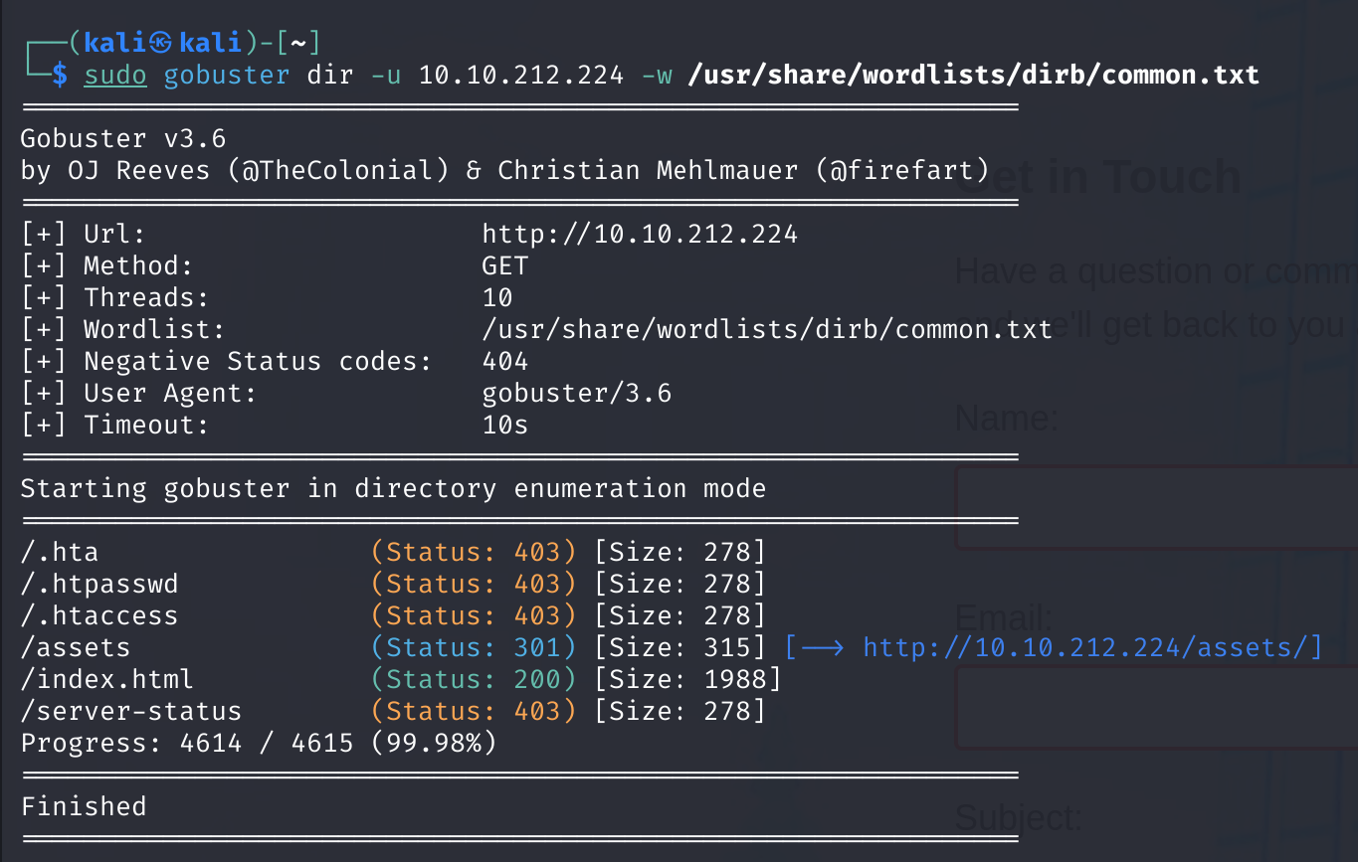

So, the 403 errors means that these are forbidden for me right now, the asset directory probably contains several things which I still don’t know, and the index page is the website start page.

Next, I navigated through the website pages and found the “contact” page which contains input text fields that look vulnerable:

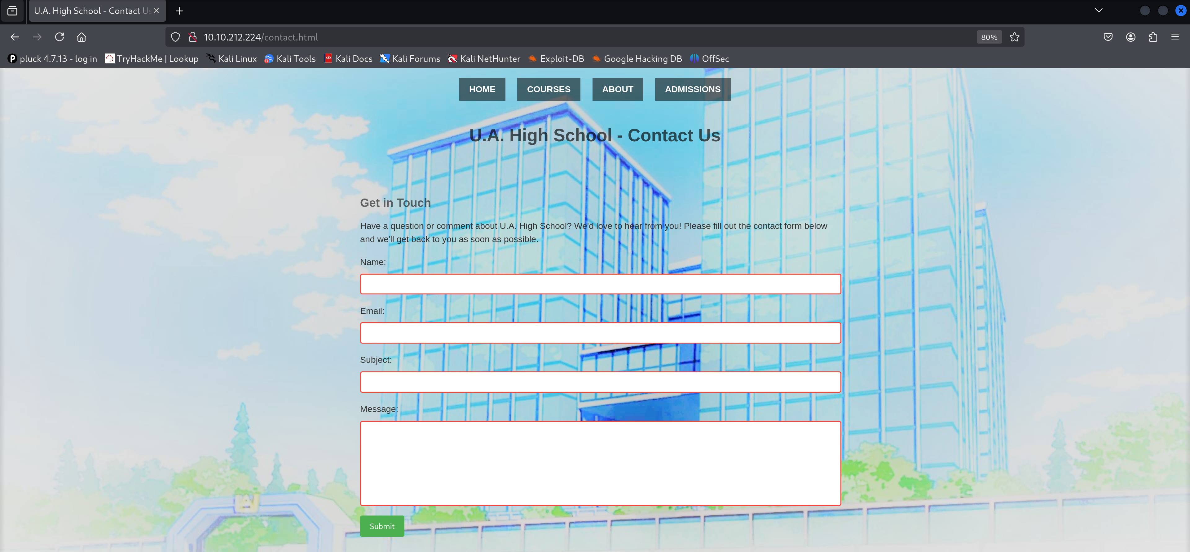

After entering some random values and clicking on the “Submit” button, I capture that contact packet using Burpsuite:

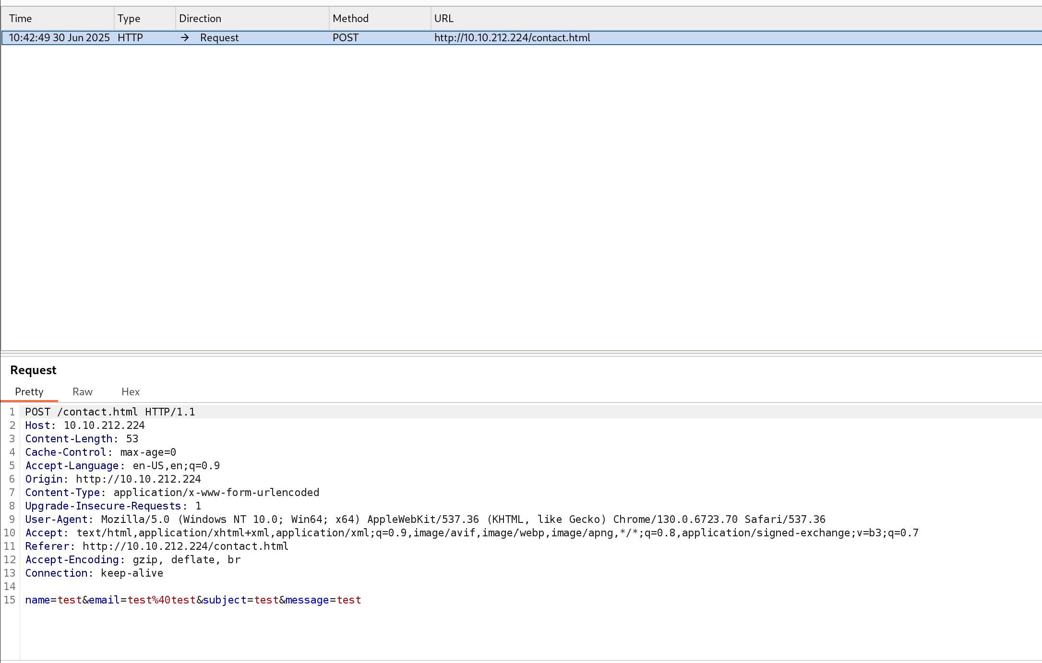

1. I found no vulnerable element, so I tried to enumerate directories in the “/assets/” directory:

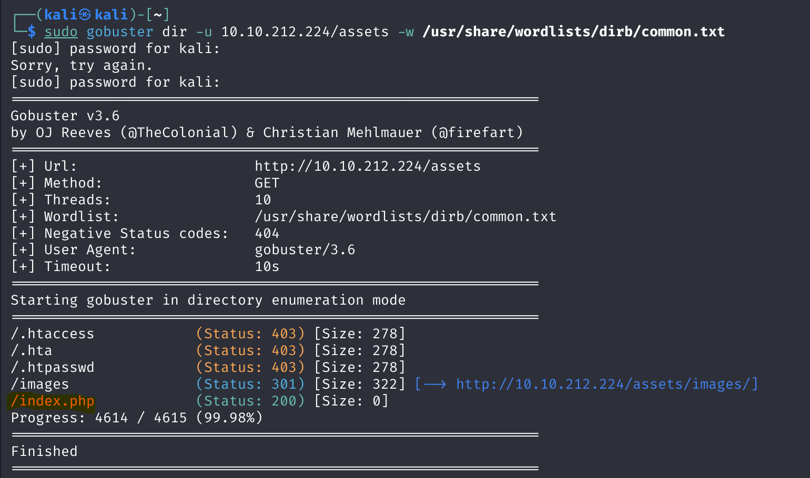

I found the “index.php” page in this directory and when I opened it I found an empty page:

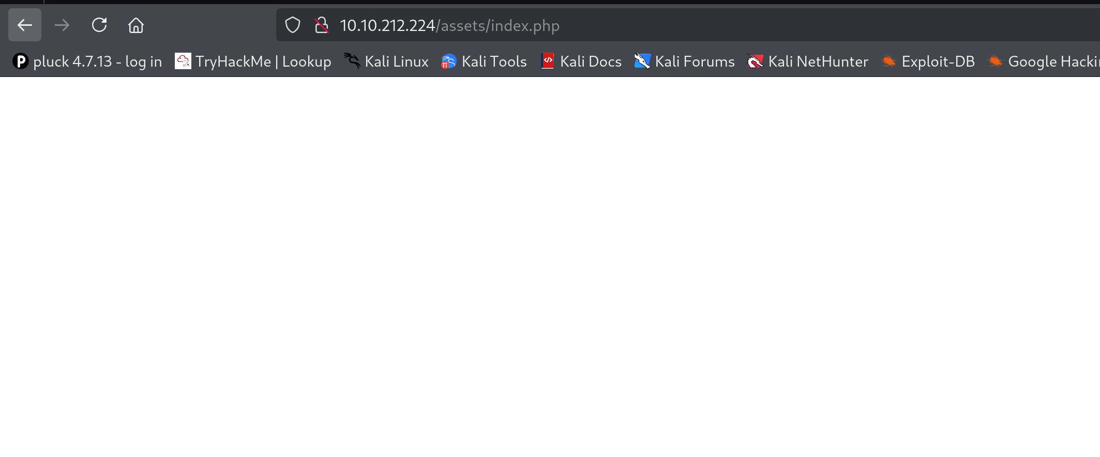

But then I remembered that an empty page can be a webshell of the target’s machine which probably runs a command like this which have the header ‘cmd’ which get input to a webshell



So, I checked the ‘id’ command using this flag over the url and it successfully gave me the results:

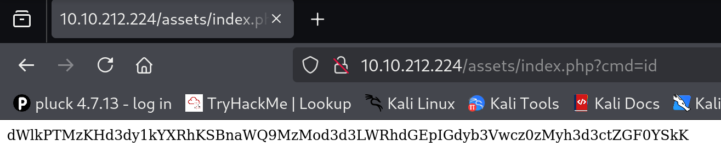

Now, I know that it doesn’t look like an appropriate output so I tried to decode it using base64 and it worked:

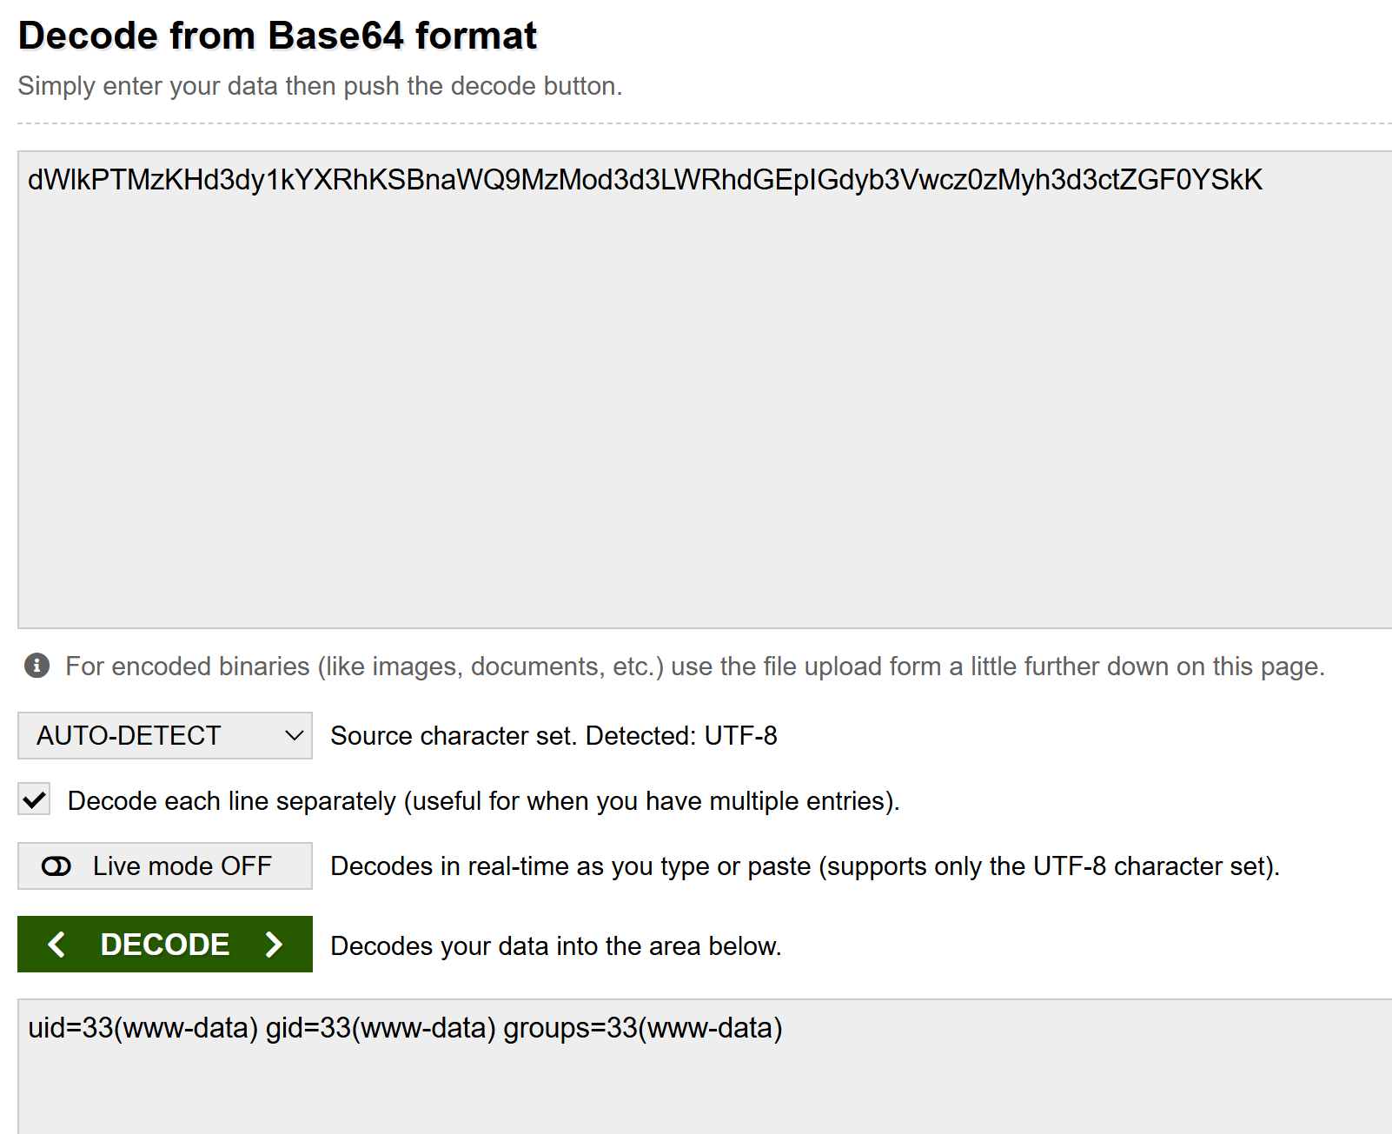

It was found to be encoded using ‘UTF-8’ cypher.

1. I found it very uncomfortable, so I used ‘netcat’ tool in order to gain a more comfortable shell over the target:

I executed this netcat listener:

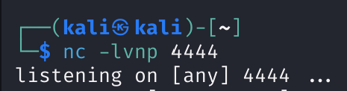

And this netcat reverse using <https://www.revshells.com/>:



I ran over the web page and got the reverse shell over the target machine in my machine:

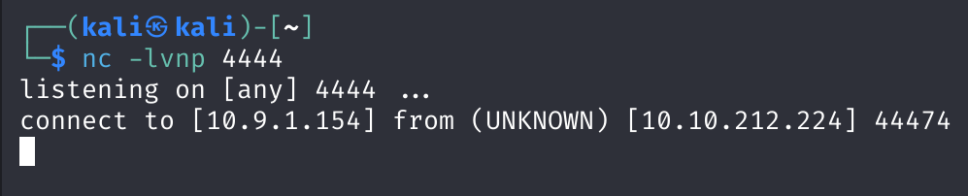

1. Now, I could navigate through the system and find the first flag file in this path: “/home/deku/user.txt”

When I tried to open it, I was faced with an error of “permission denied”:

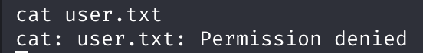

1. I left the “user.txt” file for a moment in order to transfer the images from the “/images” folder to my machine so I can see them:

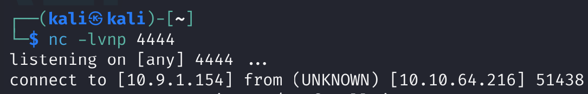

Of course, I used the rev shell command from section 4 over the target’s machine.

Now I created another listener from my machine on different port (5555) so I will be able to transfer the images:

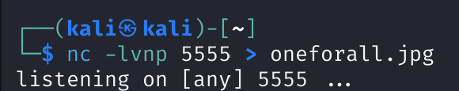

And I send the image by connecting to the netcat listener:



* Note: I did the exact same process to transfer the second image!

1. Now, after analyzing a bit the images, I understood that the “yuei.jpg” it’s just the background of the website so it’s no important for the challenge. Despite it, the “oneforall.jpg” seems to be more important due to the fact the its content was modified so it can’t be opened correctly. Moreover, I found that it was corrupted after checking the images files using the “file” utility:

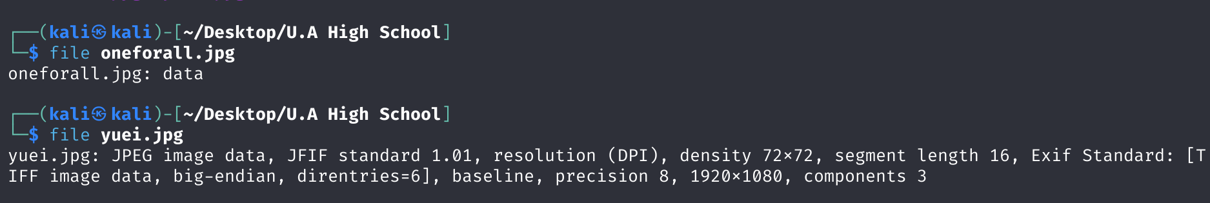

* The results of “oneforall.jpg” is just the string “data”.

1. I fixed it by opening the file in the “hexedit” tool:

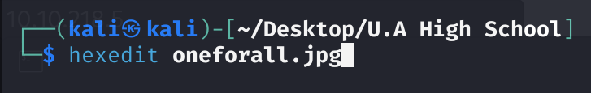

and finding that the “magic number” of the file begins with the PNG’s magic number (89 50 4E 47 0D 0A 1A 0A) and not the JPG’s magic number (FF D8 FF E0):

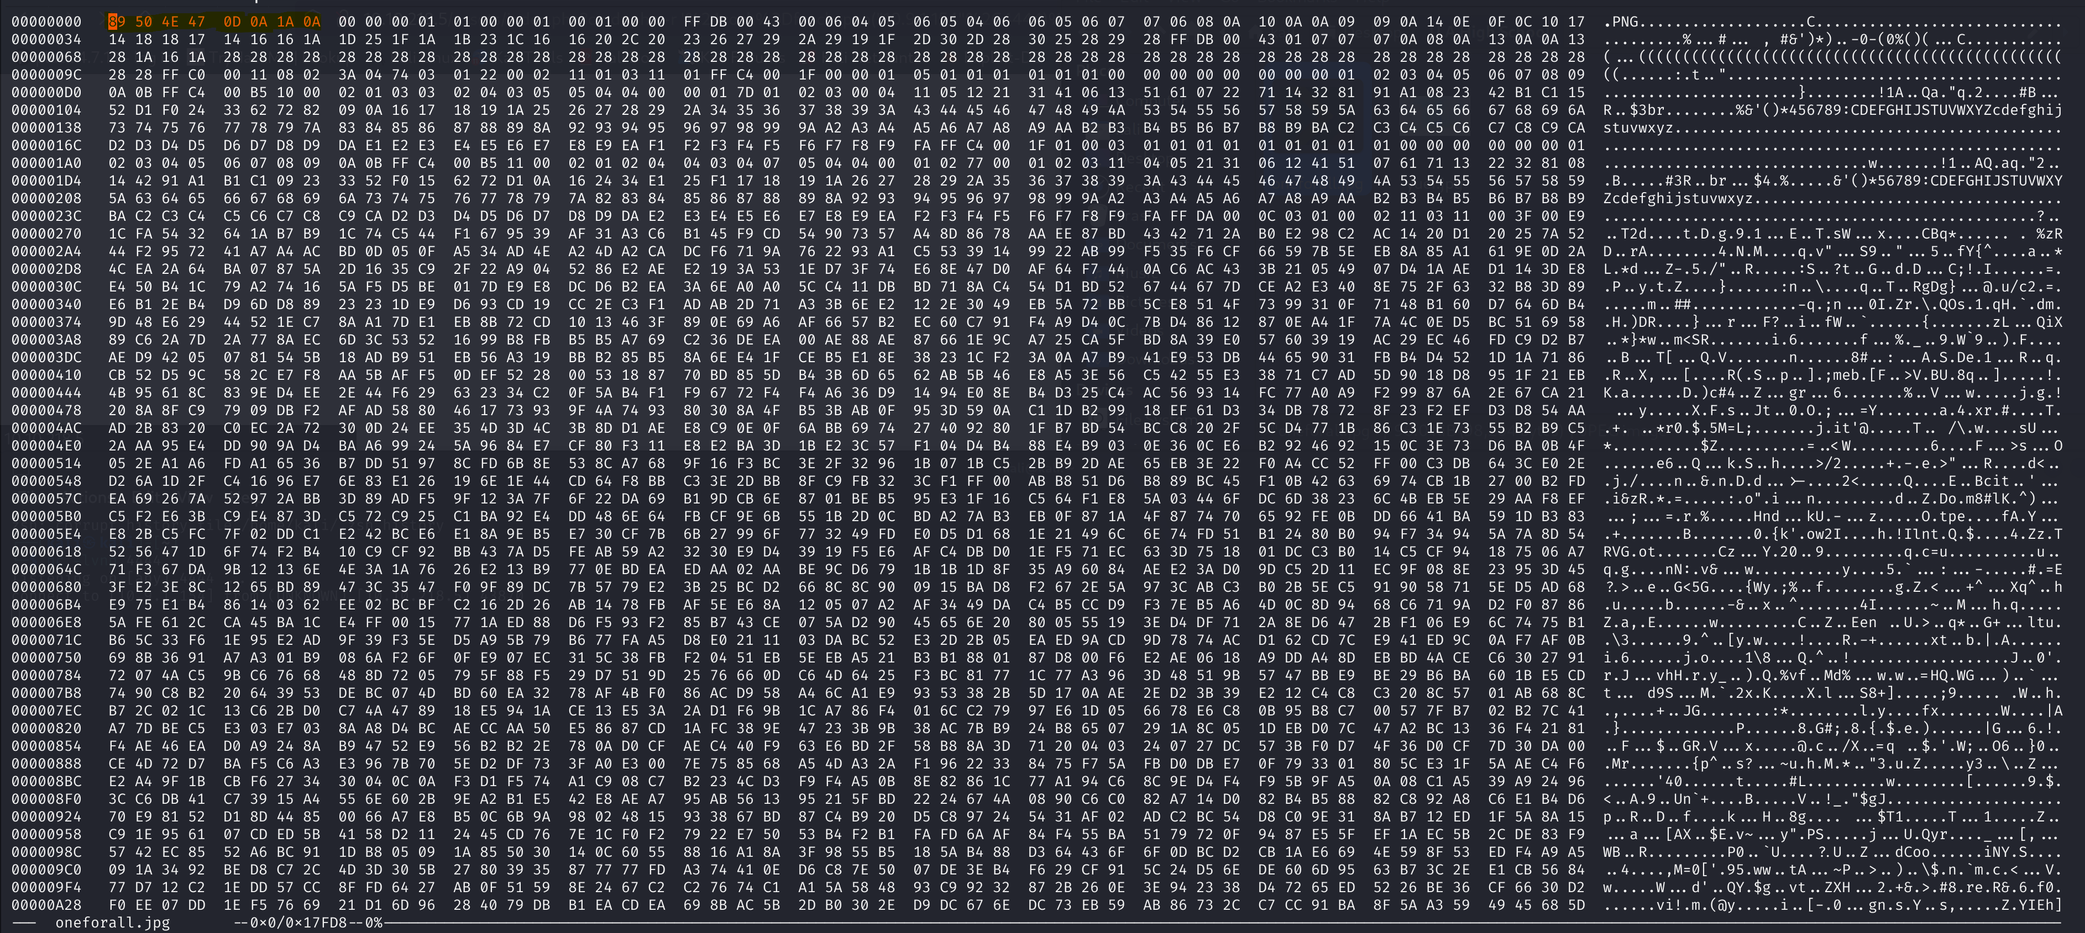

So, I change it (by pressing Ctrl+X). I found that I can’t erase the other 4 Bytes which left by the PNG magic number, so I replace them with “00 00 00 00”:

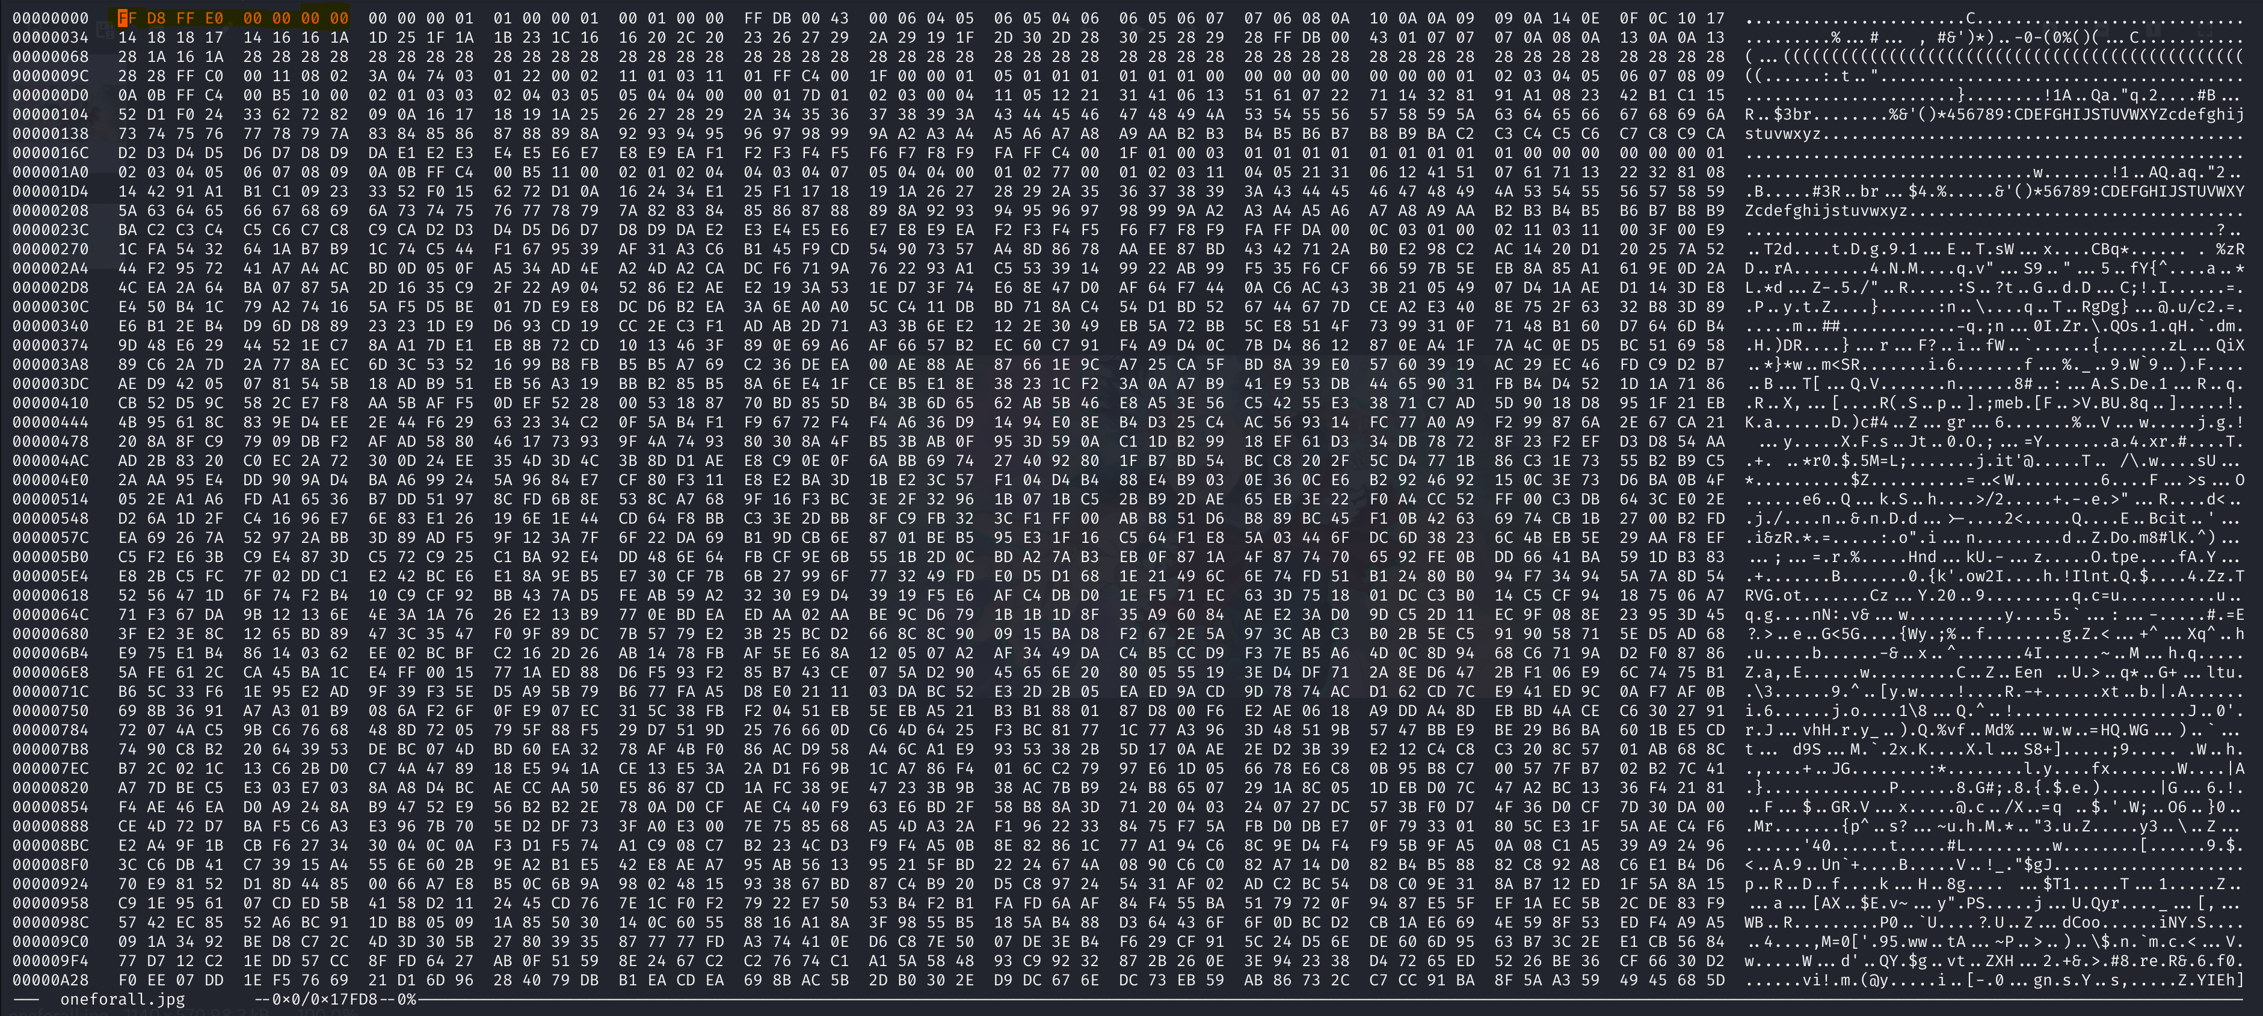

And after saving the changes, this is how the image looks like:

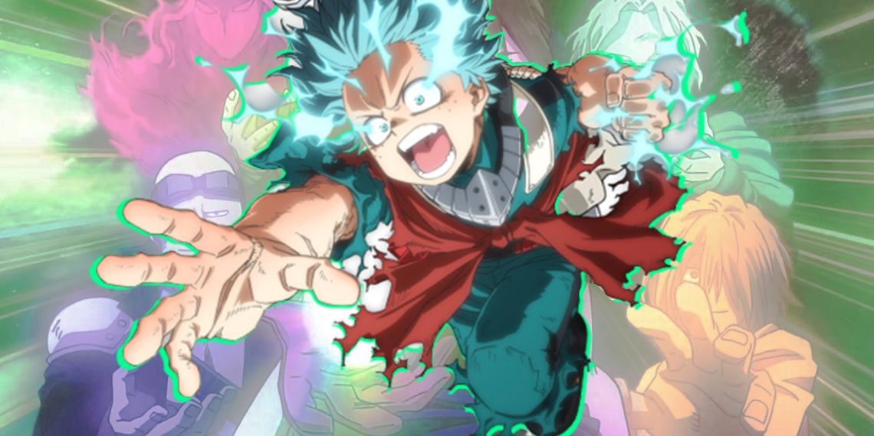

After I spend long time watching and examining the image I found nothing, so I moved to check for steganography over the image file. I used the “steghide” tool for this mission:

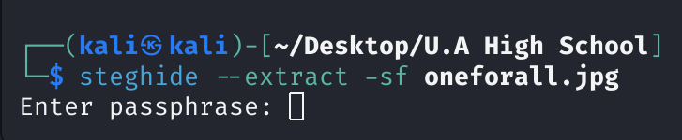

The only problem is that I need a passphrase (which is a password used to decrypt the data of the file). So, I searched a little in the file system of the victim and found the file “passphrase.txt” which located in “/var/www/Hidden_Content/”.

1. I opened the file:



and the content seemed to be encrypted to me, so I opened base64 and found its decryption:

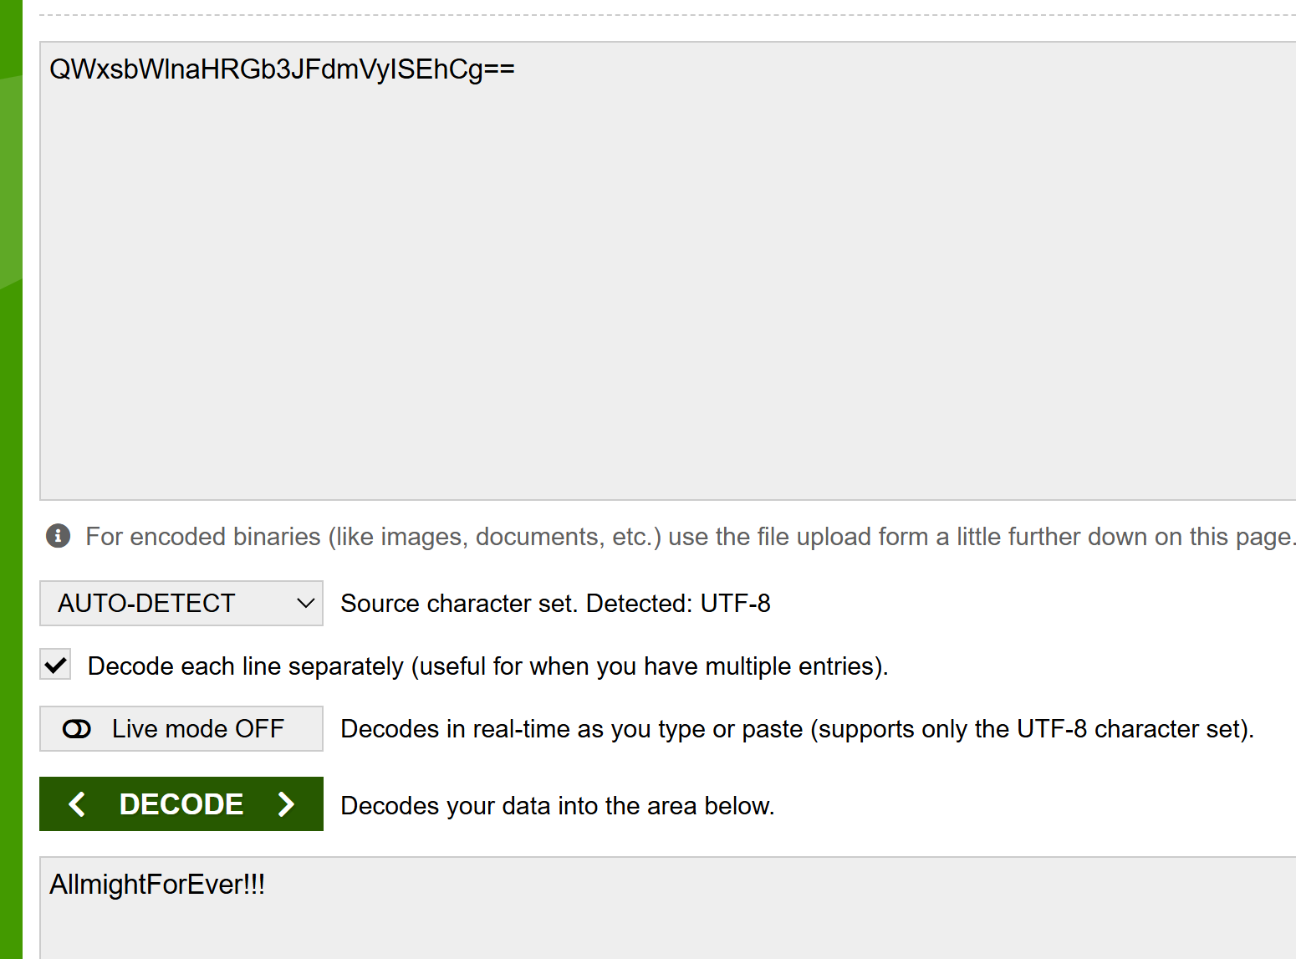

Immediately, I entered this phrase as the passphrase in the “steghide” command and this what it done:

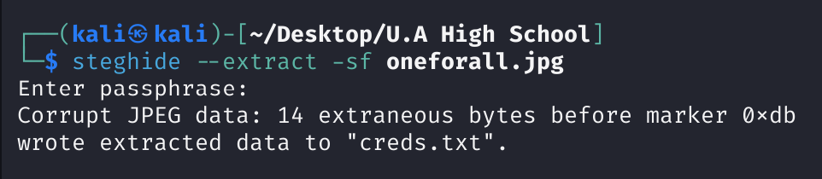

1. Of course, I opened the creds.txt file that was created and this is what I found:

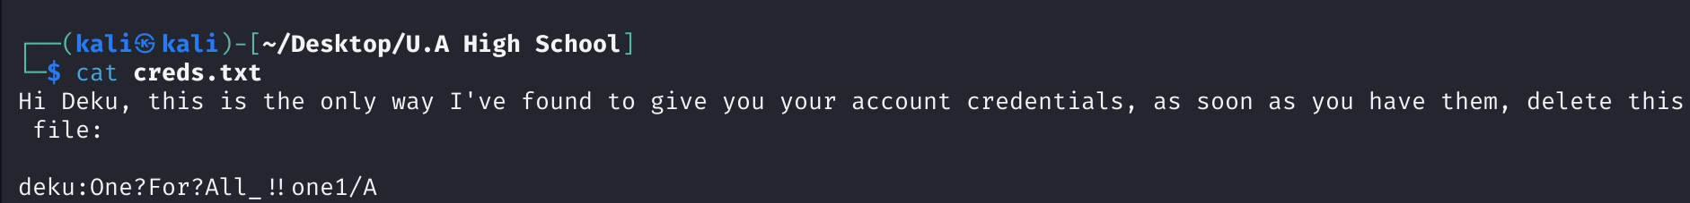

And I understood that I found deku’s credentials!!!

1. Now, all that left is to privilege escalate with his credentials (using “ssh”) and open the “user.txt” file:

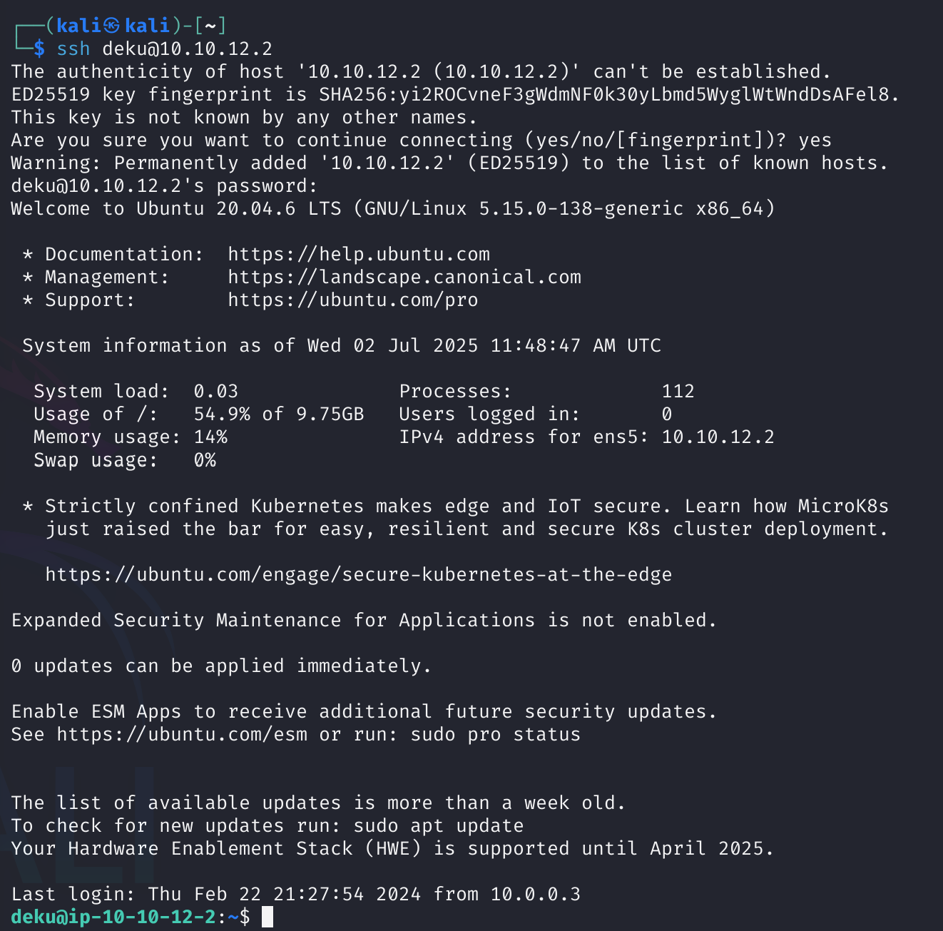

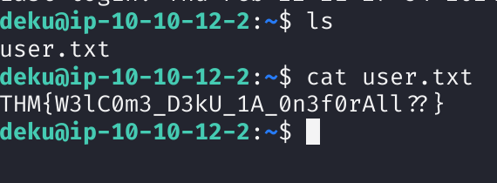

And I found the flag!

1. After this stage I moved to find the root’s flag. I started by watching my sudo permission using this sudo command:

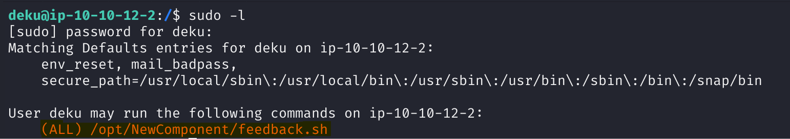

I found that I have full permission to run the feedback.sh file as a root.

Therefore, I tried to run it:

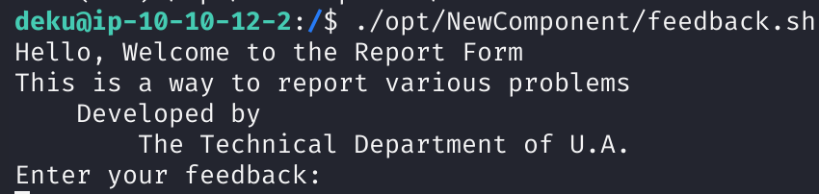

So, I gave the string “test” as an input and this what the output:

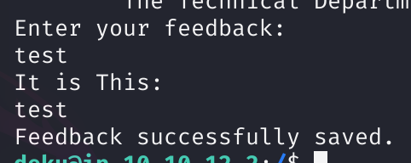

This led to open the code of the “feedback.sh” file:

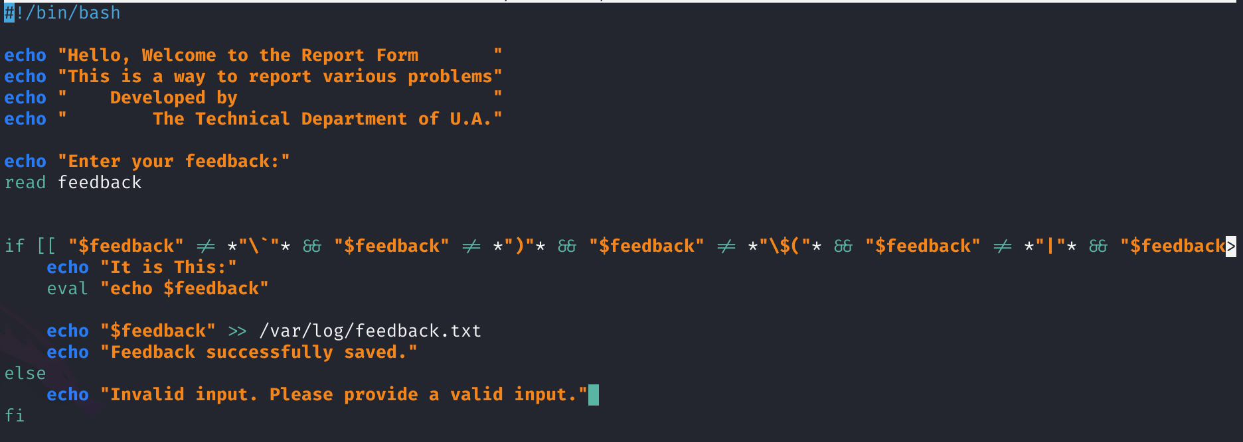

After reading it a bit I found that all the inputted feedbacks are stored on a file that named “feedback.txt” and kept in the path “/var/log/”.

I tried to open the file’s content, but I got no permission to do as root:



Therefore, I tried to chang the script so it will print the file content, but it failed because I didn’t have any permission to do it as the user “deku”.

So, I tried to find a feedback input that can help me find the file content. I noticed in line 14 that the command “eval” suppose to execute the command “echo” which suppose to print the values of the feedback parameter. I think a bit about it and realize that I can edit the “/etc/sudoers” file since I got permission to do it using this command that will give the “deku” user root privileges:

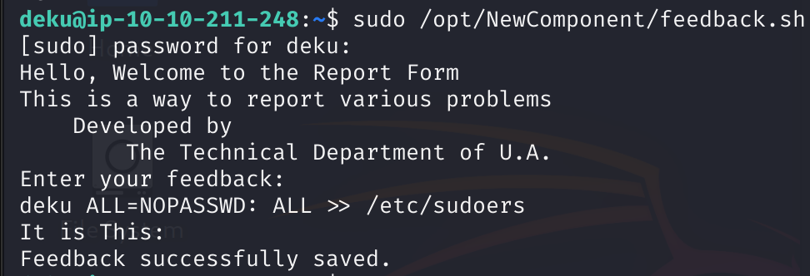

*Note: this command adds a line into the /etc/sudoers file which means that the user “deku” can have root permissions using no password.

And I checked it out using: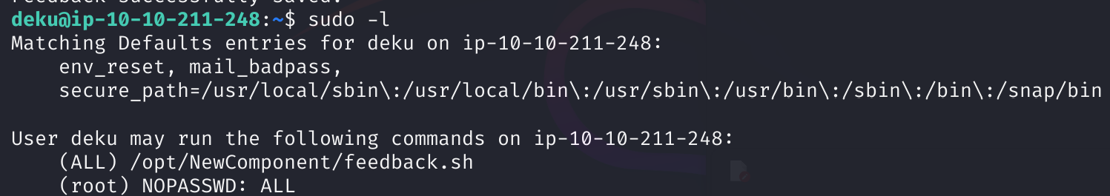

1. Now, all that is to escalate to a root, find and open the root.txt:

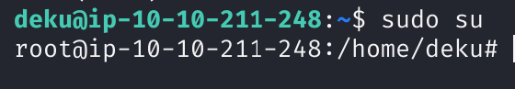



* Note: in this command, the “/” at the beginning means start from the main directory and the “2>dev/null” means any error that get received throw them into the “/dev/null” file so they won’t appear over the command output.

And after opening the root/root.txt file, I found the flag:

